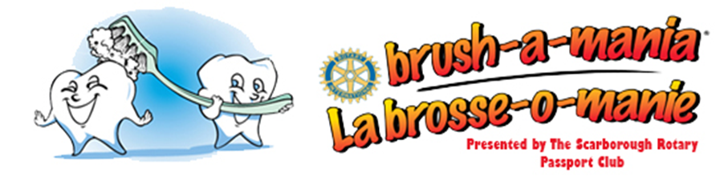
Dear Parents:

April is a very special month in Canada. It is Oral Health Month. School children across Canada from Junior Kindergarten to grade six are going to brush their teeth. Please encourage your child to brush his/her teeth.

Log on to www.brushamania.ca every day to record your child’s brushes. All elementary students up to grade 6 who brush and/or floss their teeth 100 times within any 30 day period will be emailed a Brush-a-mania certificate of achievement. His or her name will be entered into a draw to win an Xbox One or one of fifty tablets.

Please encourage your children to take good care of their teeth. April is Oral Health Month and I need you and your children to make it a BIG month. And don’t forget to have FUN!

Sincerely yours for better oral health,

Dr. Raffy Chouljian, D.D.S.
Brush-a-mania Chair
raffy@brushamania.ca

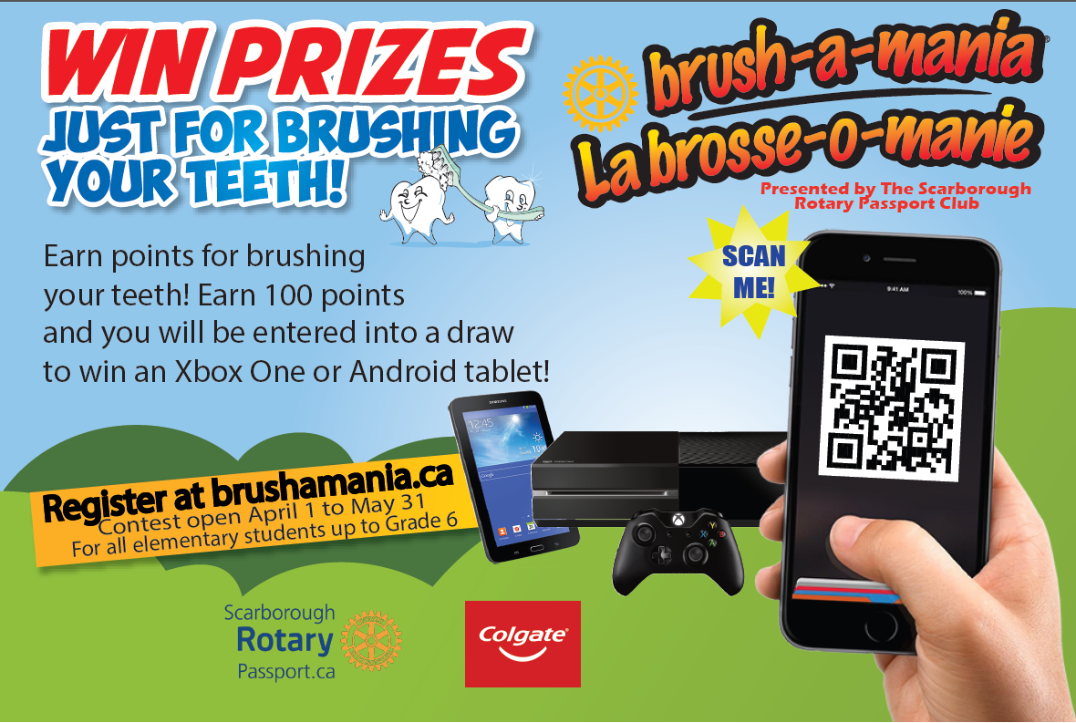

www.brushamania.ca

