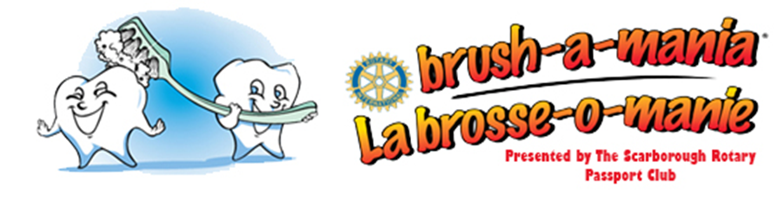
To School Principal:

Sign up now for Brush-a-mania 2021

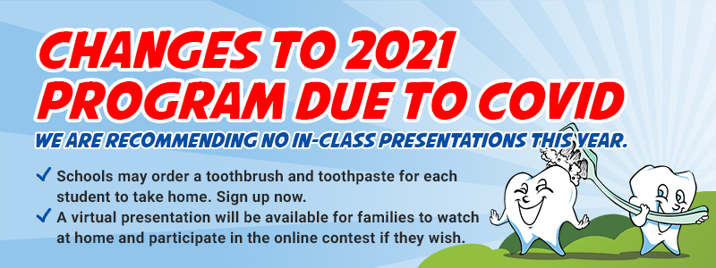

April is a very special month in Canada. It is Oral Health Month. Please help us promote good oral health amongst your students by doing the following:

- Email the attached letter to your parents after March Break;
- Distribute Colgate toothbrushes and toothpaste to your students;
- Encourage your students to brush every day and enter our Brush-a-mania online contest.

All elementary students may register and begin recording their brushes online starting April 1st. Everyone who brushes and/or flosses their teeth 100 times within any 30 day period will be emailed a Brush-a-mania certificate of achievement. His or her name will be entered into a draw to win an Xbox One or one of fifty tablets.

The goal is to encourage the students to develop good oral hygiene habits at an early age.

Sign up now for Brush-a-mania 2021

Thank you for promoting good oral health,

Dr. Raffy Chouljian, D.D.S.
Brush-a-mania Chair
raffy@brushamania.ca

Dear Parents:

April is a very special month in Canada. It is Oral Health Month. School children across Canada from Junior Kindergarten to grade six are going to brush their teeth. Please encourage your child to brush his/her teeth.

Log on to www.brushamania.ca every day to record your child’s brushes. All elementary students up to grade 6 who brush and/or floss their teeth 100 times within any 30 day period will be emailed a Brush-a-mania certificate of achievement. His or her name will be entered into a draw to win an Xbox One or one of fifty tablets.

Please encourage your children to take good care of their teeth. April is Oral Health Month and I need you and your children to make it a BIG month. And don’t forget to have FUN!

Sincerely yours for better oral health,

Dr. Raffy Chouljian, D.D.S.
Brush-a-mania Chair
raffy@brushamania.ca

